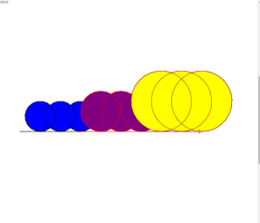

I=1

While j == 1:

sum = int(input("How many circles do you want?: "))

if amount <= 10:

j = 2

else:

print("please input a number under 10.")

continue

import turtle

myPen = turtle.Turtle()

myPen.speed(100)

myPen.color("black")

myPen.fillcolor("blue")

myPen.begin_fill()

i = 0

while i <= sum:

myPen.forward(60)

myPen.circle(45)

i = i + 1

myPen.end_fill()

myPen.color("red")

myPen.fillcolor("purple")

myPen.begin_fill()

i = 0

while i <= sum:

myPen.forward(60)

myPen.circle(60)

i = i + 1

myPen.end_fill()

myPen.color("red")

myPen.fillcolor("yellow")

myPen.begin_fill()

i = 0

while i <= sum:

myPen.forward(60)

myPen.circle(90)

i = i + 1

myPen.end_fill()